Config-Driven Agentic Platform

Enterprise Reference Architecture using LangGraph4j + Spring AI + MCP

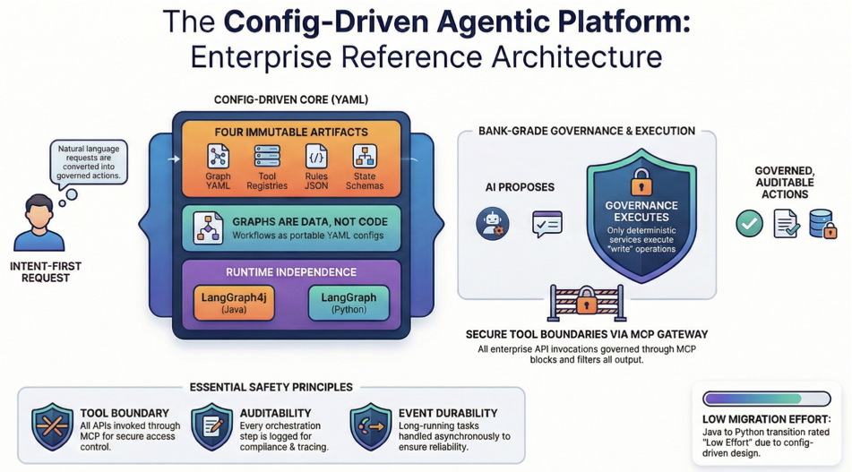

1. Purpose
The purpose of this platform is to enable Intent-First enterprise applications where users interact using natural language while the system safely orchestrates internal services.
Example user requests:
- “Apply leave from 5 to 8 June”
- “Submit this medical receipt”
- “Why is my salary deduction higher this month?”
The platform converts these intents into governed, auditable actions across enterprise systems.
Key goals:
- Enable AI-assisted employee workflows
- Maintain enterprise governance
- Provide safe execution boundaries
- Support future portability (Java → Python → Cloud)
The architecture is config-driven, meaning workflows are defined in graph configuration instead of hard-coded logic.
Config Driven AgenticPlatform

2. Core Architecture Philosophy
The platform follows three core principles.

2.1 Config-Driven Workflows
Graphs are data, not code.
graphs → YAML configuration
runtime → execution engine
nodes → plugins
This enables portability across runtimes.

2.2 Portable Architecture Layer

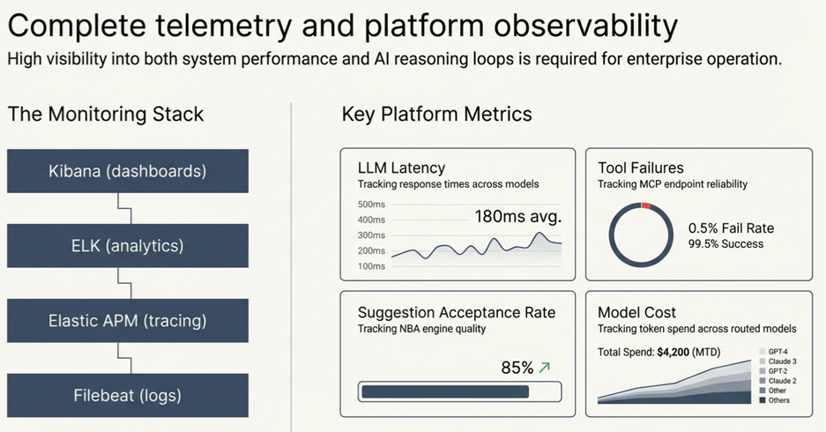
Three artifacts must remain stable.
Config Driven AgenticPlatform
Artifact | Purpose
Graph YAML | workflow definition
Tool registry | enterprise API mapping
Rules JSON | policy enforcement
State schema | shared execution context
Everything else can change.

2.3 Runtime Independence

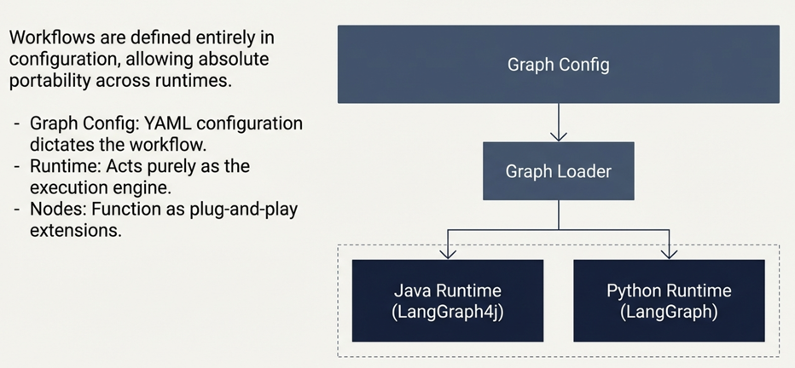
Graph Config
│
▼
Graph Loader
│
┌───┴───────────────┐
▼ ▼
Java Runtime Python Runtime
LangGraph4j LangGraph
Both runtimes interpret the same configuration.
Config Driven AgenticPlatform

3. Design Principles (Bank-Grade)
Principle | Explanation
AI proposes | Agents suggest actions
Governance executes | Only deterministic services execute writes
Tool boundary | All APIs invoked through MCP
Event durability | Long tasks handled asynchronously
Auditability | Every step logged

4. System Architecture

High Level Components
Employee / Staff
│
▼
SmartBar UI
│
▼
Intent Handler (Spring Boot)
│
▼
Agentic Platform
LangGraph4j Runtime
│
▼
Spring AI
│
▼
LLM Gateway
│
▼
MCP Gateway
│
▼
Enterprise APIs

5. Core Platform Components

5.1 SmartBar UI
Provides conversational interface.
Capabilities:
- natural language input
- smart typing suggestions
- slot-filling UI chips
- suggestion cards
Example:
Grant websurf access to John for Project X till 31 March

5.2 Intent Handler (IH)
Primary governance service.
Responsibilities:
Function | Description
session creation | user context
RBAC checks | authorization
policy checks | deterministic rules
graph routing | select workflow
execution control | approve write operations

5.3 Agent Platform (LangGraph4j)
Responsible for agent orchestration.
Capabilities:
- graph execution
- reasoning loops
- node orchestration
- state propagation
Example flow:
Intent extraction
↓
Domain enrichment
↓
Policy validation
↓
Suggestion engine
↓
Response rendering

5.4 Spring AI Layer
Provides LLM abstraction.
Features:
Capability | Usage
model abstraction | OpenAI / Claude
prompt templates | standard prompts
tool calling | structured function calls
embedding support | vector search

5.5 LLM Gateway
Optional model router.
Responsibilities:
Function | Purpose
model routing | best model per task
fallback | reliability
cost optimization | cheaper models
response normalization | unified output

5.6 MCP Gateway
Secure boundary for enterprise APIs.
Capabilities:
Feature | Description
tool registry | API catalog
schema validation | enforce contracts
access control | security checks
audit logs | compliance trace
Example tool:
tool: hris.leave.balance
endpoint: /api/hr/leave/balance
method: GET

6. Configuration Artifacts

6.1 Graph Configuration (YAML)
Example:
graphId: leave_apply_v1
version: 1
nodes:
- id: A_INTENT
type: intent_extractor
next: ENRICH_HRIS
- id: ENRICH_HRIS
type: tool_read
tools:
- hris.leave.balance
- hris.holiday.calendar
next: POLICY_CHECK
- id: POLICY_CHECK
type: rule_eval
rules:
- leave.eligibility.v0
next: SUGGEST_OR_COMPLETE
end: RENDER_RESPONSE

6.2 Tool Registry (Postgres)
tool_id | endpoint | method | type
hris.leave.balance | /leave/balance | GET | READ
claims.submit | /claims | POST | WRITE

6.3 Rules JSON
Example rule:
{
"rule_id": "leave.eligibility.v0",
"condition": "leave_balance >= requested_days",
"deny_reason": "INSUFFICIENT_BALANCE"
}

7. Detailed Example — Leave Application

User Intent
Apply leave from 10 May to 15 May

Graph Execution
A_INTENT
↓
ENRICH_HRIS
↓
POLICY_CHECK
↓
SUGGEST_OR_COMPLETE
↓
RENDER_CONFIRMATION

Node Configuration

Intent Extraction
type: intent_extractor
model: gpt-4o
output_schema:
intent
start_date
end_date

HRIS Enrichment
Tools invoked:
hris.leave.balance
hris.holiday.calendar
hris.manager.lookup

Policy Evaluation
Rules applied:
Rule | Description
leave.eligibility.v0 | balance validation
leave.blackout.v0 | blackout period
leave.cutoff.window.v0 | cutoff deadline

Suggestions
Examples:
Situation | Suggestion
missing start date | propose next Monday
insufficient balance | split leave

Final Output
Leave request detected
Start Date: 10 May
End Date: 15 May
Leave Balance: 8 days
Suggested Action:
Submit leave request for manager approval

8. Detailed Example — Claim Submission

User Intent
Submit this medical receipt
Attachment: PDF receipt.

Graph Flow
A_INTENT
↓
PARSE_RECEIPT
↓
ENRICH_CLAIMS
↓
POLICY_CHECK
↓
SUGGEST_OR_COMPLETE
↓
RENDER_CONFIRMATION

Receipt Parsing
Tool:
docai.receipt.extract
Extracted fields:
Field | Value
provider | Clinic ABC
amount | 120
date | 12 April

Policy Checks
Rule | Description
claims.cap.v0 | claim cap
claims.duplicate.v0 | duplicate detection
claims.provider.whitelist | approved clinics

Suggestions
Situation | Suggestion
missing category | suggest medical claim
exceeds cap | partial claim

Final Response
Medical receipt detected
Provider: Clinic ABC
Amount: $120
Date: 12 April
Eligible for reimbursement.
Action:
Submit claim for approval

9. Observability
Monitoring stack:
Tool | Purpose
Elastic APM | tracing
Filebeat | logs
ELK | analytics
Kibana | dashboards
Metrics:
- LLM latency
- tool failures
- suggestion acceptance rate
- model cost

10. Migration Strategy
Because workflows are configuration-driven:
Migration | Effort
Java → Hybrid Python | Low
Hybrid → Python dominant | Medium
On-prem → Cloud | Medium
The following remain unchanged.
Config Driven AgenticPlatform
- graph YAML
- tool registry
- state schema

11. Strategic Benefits
Benefit | Explanation
Language independence | Java or Python runtime
Cloud portability | OpenShift or AWS
Low coupling | nodes evolve independently
Governance | execution controlled
This architecture prevents lock-in across:
Lock-in | Avoided by
Language | config graphs
Vendor | MCP tool layer
Cloud | portable runtime

If you want, I can also generate three additional artifacts useful for your architecture presentation:
1️⃣ Full end-to-end PUML architecture diagram
2️⃣ PUML sequence diagrams for Leave + Claims flows
3️⃣ Graph designer schema showing how architects visually build these workflows.
Sources
PUML sequence diagrams for Leave + Claims flows
Below are clean, renderable PUML sequence diagrams for the two flows.
They follow your architecture:
- SmartBar UI
- Intent Handler (IH)
- Agent Platform (LangGraph4j)
- Spring AI / LLM Gateway
- MCP Tool Gateway
- Enterprise Systems
These diagrams are simplified enough for architecture decks but still technically accurate.

1️⃣ Leave Application Flow (PUML Sequence)
@startuml
title IFEX SmartBar — Leave Application Flow
actor Employee as EMP
participant "SmartBar UI" as UI
participant "Intent Handler\n(Spring Boot)" as IH
participant "Agent Platform\n(LangGraph4j)" as AP
participant "Spring AI\nLLM Adapter" as LLM
participant "MCP Gateway\nTool Boundary" as MCP
participant "HRIS System" as HRIS
participant "Workflow Service\n(Approval)" as WF
EMP -> UI : "Apply leave from 10–15 May"
UI -> IH : IntentRequest\n(user context + text)
IH -> AP : Run graph: leave_apply_v1
AP -> LLM : Extract intent & entities
LLM --> AP : intent=leave.apply\nstart=10 May\nend=15 May
AP -> MCP : tool: hris.leave.balance
MCP -> HRIS : GET /leave/balance
HRIS --> MCP : balance=8
MCP --> AP : leave_balance
AP -> MCP : tool: hris.holiday.calendar
MCP -> HRIS : GET /holiday/calendar
HRIS --> MCP : holidays
MCP --> AP : holiday_list
AP -> AP : Evaluate policy rules\nleave.eligibility.v0
alt insufficient balance
AP -> LLM : Generate suggestion
LLM --> AP : Suggest unpaid leave
end
AP --> IH : ProposedResult\nLeave request + suggestions
IH -> WF : Create approval request
WF --> IH : approvalId
IH --> UI : Confirmation\n"Leave submitted for approval"
@enduml

2️⃣ Claim Submission Flow (PUML Sequence)
@startuml
title IFEX SmartBar — Claim Submission Flow
actor Employee as EMP
participant "SmartBar UI" as UI
participant "Intent Handler\n(Spring Boot)" as IH
participant "Agent Platform\n(LangGraph4j)" as AP
participant "Doc AI Agent\n(OCR Service)" as OCR
participant "Spring AI\nLLM Adapter" as LLM
participant "MCP Gateway\nTool Boundary" as MCP
participant "Claims System" as CLAIMS
EMP -> UI : Upload receipt\n"Submit this medical claim"
UI -> IH : IntentRequest\n(file + user context)
IH -> AP : Run graph: claim_submit_v1
AP -> OCR : Parse receipt PDF
OCR --> AP : provider=Clinic ABC\namount=120\n date=12 Apr
AP -> MCP : tool: claims.policy.lookup
MCP -> CLAIMS : GET /claim/policy
CLAIMS --> MCP : claim rules
MCP --> AP : policy rules
AP -> AP : Evaluate policy\ncap / duplicate / provider
alt exceeds cap
AP -> LLM : Generate alternative suggestion
LLM --> AP : Suggest partial claim
end
AP -> MCP : tool: claims.submit
MCP -> CLAIMS : POST /claims
CLAIMS --> MCP : claimId
MCP --> AP : claim confirmation
AP --> IH : ProposedResult\nclaim submitted
IH --> UI : Claim submitted\nClaim ID displayed
@enduml

What These Diagrams Show (Important for Architecture Review)

Deterministic governance
Only Intent Handler executes final actions.

AI boundary
LLM is used only for:
- intent extraction
- suggestion generation

Safe tool invocation
All enterprise APIs are accessed via MCP Gateway.

Policy control
Rules are evaluated before execution.

If you want, I can also generate the third diagram that architects usually ask for:
Agent Graph Planner Diagram (LangGraph nodes) for:
leave_apply_v1
claim_submit_v1
This shows the actual agent nodes and edges, which complements the sequence diagrams and is usually required in architecture review.
Agent Graph Planner Diagram (LangGraph nodes) for: leave_apply_v1 claim_submit_v1
Below are clean PUML diagrams showing the LangGraph planner (nodes + edges) for the two workflows you asked for.
These represent the agent graph executed by the Agent Platform using LangGraph4j.
These are graph diagrams (not sequence diagrams) and are typically used in architecture reviews to explain how agents collaborate to complete an intent.

1️⃣ Leave Application — Agent Graph Planner
@startuml
title LangGraph Planner — leave_apply_v1
skinparam shadowing false
skinparam componentStyle rectangle
left to right direction
component "START" as START
component "A_INTENT\nIntent + Entity Extraction\n(Spring AI + LLM)" as AINT
component "ENRICH_HRIS\nTool Read\nLeave Balance\nHoliday Calendar\nManager Lookup" as ENRICH
component "POLICY_CHECK\nRule Engine\nEligibility / Blackout / Cutoff" as POLICY
component "SUGGEST_OR_COMPLETE\nSmart Suggestions\nMissing fields / Split leave" as SUGG
component "PREPARE_SUBMIT\nFeature Flag Check\nleave.submit.enabled" as FLAG
component "RENDER_CONFIRMATION\nRender UI JSON" as CONFIRM
component "RENDER_CLARIFICATION\nAsk Missing Info" as CLARIFY
component "RENDER_DENY\nPolicy Violation Response" as DENY
component "END" as END
START --> AINT
AINT --> ENRICH
ENRICH --> POLICY
POLICY --> DENY : rule.status = DENY
POLICY --> SUGG : rule.status = PASS
SUGG --> CLARIFY : missing_fields > 0
SUGG --> FLAG : all fields present
FLAG --> CONFIRM : feature enabled
FLAG --> CLARIFY : feature disabled
CONFIRM --> END
CLARIFY --> END
DENY --> END
@enduml

2️⃣ Claim Submission — Agent Graph Planner
@startuml
title LangGraph Planner — claim_submit_v1
skinparam shadowing false
skinparam componentStyle rectangle
left to right direction
component "START" as START
component "A_INTENT\nIntent Detection\nClaim Submission" as AINT
component "PARSE_RECEIPT\nDocAI Agent\nOCR / PDF Parsing" as PARSE
component "ENRICH_CLAIMS\nTool Read\nClaim Limits / History" as ENRICH
component "POLICY_CHECK\nRule Engine\nCap / Duplicate / Provider" as POLICY
component "SUGGEST_OR_COMPLETE\nSuggestions\nPartial Claim / Category" as SUGG
component "PREPARE_SUBMIT\nFeature Flag Check\nclaim.submit.enabled" as FLAG
component "RENDER_CONFIRMATION\nUI JSON Response" as CONFIRM
component "RENDER_CLARIFICATION\nMissing Data Request" as CLARIFY
component "RENDER_DENY\nPolicy Violation" as DENY
component "END" as END
START --> AINT
AINT --> PARSE
PARSE --> ENRICH
ENRICH --> POLICY
POLICY --> DENY : rule.status = DENY
POLICY --> SUGG : rule.status = PASS
SUGG --> CLARIFY : missing_fields > 0
SUGG --> FLAG : valid submission
FLAG --> CONFIRM : feature enabled
FLAG --> CLARIFY : feature disabled
CONFIRM --> END
CLARIFY --> END
DENY --> END
@enduml

How These Graphs Map to Your Platform
Graph Node | Actual Implementation
A_INTENT | Spring AI prompt → LLM extraction
ENRICH_* | MCP tool calls
POLICY_CHECK | JSON rules engine
SUGGEST_OR_COMPLETE | NBA engine
PARSE_RECEIPT | OCR / DocAI service
RENDER_* | UI response generator

Why This Graph Approach Works Well
Key advantages:
Benefit | Explanation
Transparent workflows | Graph visually explains decision flow
Governance | Deterministic policy nodes
Reusable agents | Same nodes reused across graphs
Safe execution | Tool calls isolated via MCP
Config-driven | Graph stored as YAML

What Management Usually Likes Seeing Next
For presentations, the most powerful diagram after this is the “Full Agentic Platform Architecture” showing how these graphs execute across services.
That diagram typically looks like:
SmartBar
↓
Intent Handler
↓
Agent Platform (LangGraph)
↓
LLM Gateway
↓
MCP Tool Layer
↓
Enterprise Systems
If you'd like, I can also generate a very clean “board-level architecture diagram” for the entire platform that combines:
- SmartBar
- Intent Handler
- Agent Platform
- LLM Gateway
- MCP
- Kafka
- Enterprise APIs
It usually becomes the single slide that explains the entire architecture clearly.

Meaning:
- graphs are data
- runtime is engine
- nodes are plugins
Config contain:
Config | Why
graph nodes | workflow
edges | routing
rules IDs | policy
tool IDs | API mapping

Guiding Principle
Three things must remain stable and portable:
1️⃣ Graph definitions (YAML/JSON)
2️⃣ Tool contracts (API schemas)
3️⃣ State model (AgentState schema)
Everything else can change.
Portable Layer
------------------------------
Graph YAML
Tool Registry
Rules JSON
State Schema
------------------------------
Runtime Layer
Java LangGraph4j
Python LangGraph
AWS Bedrock Agents

Phase 1 - Hybrid approach

Java handles:
✔ governance
✔ approvals
✔ permission checks
✔ Submission routing/ execution
Python handles:
✔ reasoning
✔ parsing
✔ RAG

